Broker Pattern
# Source: AI Source: Provided by: [Data Path: Persons Table -> ID Column: 1, Name_En Column: Motasem Essam] -> From: [ChatGPT] on [1/23/2026]
The Broker Pattern is an architectural pattern used to structure distributed systems where components communicate indirectly via a broker, rather than directly with each other.
👉 Think of it as a messaging hub that routes requests and responses between clients and servers.

🔑 Key Idea
# Source: AI Source: Provided by: [Data Path: Persons Table -> ID Column: 1, Name_En Column: Motasem Essam] -> From: [ChatGPT] on [1/23/2026]
- Components are decoupled
- Communication goes through a broker
- Broker handles request routing, message transformation, and coordination

🧱 Structure
# Source: AI Source: Provided by: [Data Path: Persons Table -> ID Column: 1, Name_En Column: Motasem Essam] -> From: [ChatGPT] on [1/23/2026]
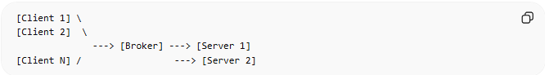
[Client 1] \
[Client 2] \
---> [Broker] ---> [Server 1]
[Client N] / ---> [Server 2]
- Clients → Send requests
- Broker → Routes requests, manages communication
- Servers → Process requests and return responses

🧩 Example – Messaging System
# Source: AI Source: Provided by: [Data Path: Persons Table -> ID Column: 1, Name_En Column: Motasem Essam] -> From: [ChatGPT] on [1/23/2026]
- Clients → Chat apps sending messages
- Broker → Message queue (like RabbitMQ, Kafka)
- Servers → Services that process messages (e.g., notifications, logging)
Client sends message → Broker queues message → Server processes → Response sent back

❌ Bad Example (No Broker)
# Source: AI Source: Provided by: [Data Path: Persons Table -> ID Column: 1, Name_En Column: Motasem Essam] -> From: [ChatGPT] on [1/23/2026]
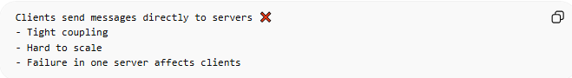
Clients send messages directly to servers ❌
- Tight coupling
- Hard to scale
- Failure in one server affects clients

✅ Good Example (With Broker)
# Source: AI Source: Provided by: [Data Path: Persons Table -> ID Column: 1, Name_En Column: Motasem Essam] -> From: [ChatGPT] on [1/23/2026]
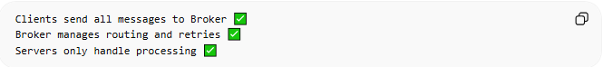
Clients send all messages to Broker ✅
Broker manages routing and retries ✅
Servers only handle processing ✅

🔄 Use Cases
# Source: AI Source: Provided by: [Data Path: Persons Table -> ID Column: 1, Name_En Column: Motasem Essam] -> From: [ChatGPT] on [1/23/2026]
- Enterprise messaging systems
- Event-driven architectures
- Middleware in distributed applications
- Microservices communication

⚠️ Common Mistakes
# Source: AI Source: Provided by: [Data Path: Persons Table -> ID Column: 1, Name_En Column: Motasem Essam] -> From: [ChatGPT] on [1/23/2026]
- Making the broker a single point of failure ❌
- Overloading the broker with too much logic ❌
- Clients knowing too much about server locations ❌

💡 Key Idea
# Source: AI Source: Provided by: [Data Path: Persons Table -> ID Column: 1, Name_En Column: Motasem Essam] -> From: [ChatGPT] on [1/23/2026]
The Broker Pattern decouples clients and servers, centralizing communication and routing through a broker, which simplifies distributed system management.

🧾 Summary
# Source: AI Source: Provided by: [Data Path: Persons Table -> ID Column: 1, Name_En Column: Motasem Essam] -> From: [ChatGPT] on [1/23/2026]
- Broker → Routes requests between components
- Clients → Send requests
- Servers → Process requests
- Benefits: scalable, decoupled, and maintainable distributed systems

